Alt-Controller Research:

Game 1 – People of the Moon:

URL - https://shakethatbutton.com/people-of-the-moon/

Screenshots
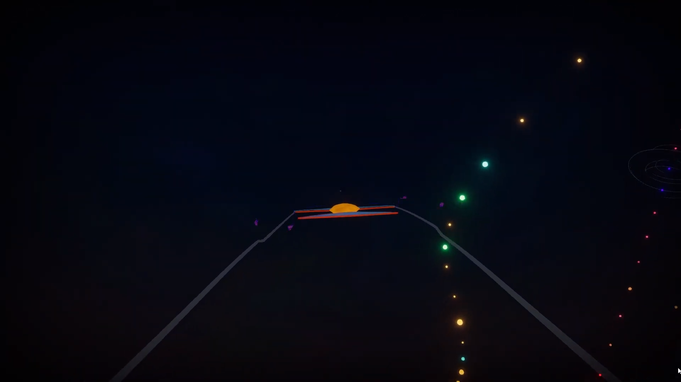

Description
It’s a two-player co-op game. The two players sit on a custom-built seesaw and use levers to control their spaceship in order to collect all the lights.

What I find interesting
The fact that the players have to use a seesaw as a game controller.

Game 2 - Hellcouch:

URL - https://shakethatbutton.com/hellcouch/

Screenshots
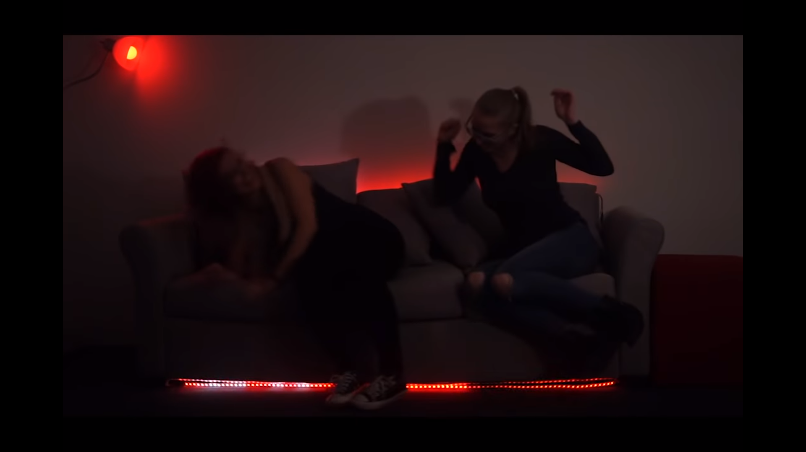

Description
A Co-Op game where the story is that a demon has been trapped in a couch and players have to “perform a secret butt ritual” to release the demon from his cosy prison. In essence, the players have to sit on the indicated parts of their sofa. They are given both visual and audio aids from LEDs and speakers.

What I find interesting
That the players spend the entire game jumping on the sofa

Game 3 - Frite Fight:

URL - https://shakethatbutton.com/frite-fight/

Screenshots
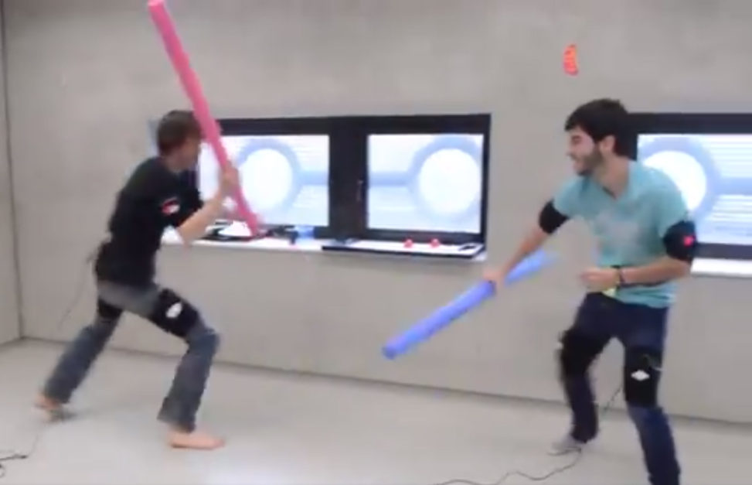

Description
Multiplayer game where the two players has to hit each other with swimming noodles at specific points on their opponents’ body (where the sensors are) to earn points.

What I find interesting
The fact that the players hit each other with pretend lightsabres.

Game idea:

Blow into sensor to make sails go forward (use mic or some sort of windmill for sensor)
Either get a crank or some sort of lever for direction
Get button for firing cannons

